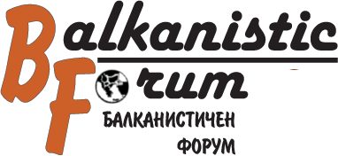
The International University Seminar for Balkan Studies and Specialization
to the South-Western University “Neophyte Rilsky”, Blagoevgrad
Invites you to take part in
the 23rd International Round Table

“SILENCE ON THE BALKAN”

which will be held on 24. 04 - 26. 04. 2014
In the center of the discussions we would like to place the culture of silence and the ways of overcoming silence by creating possibilities for dialogue. The following problems will be discussed:

- Power, suppression, dominant culture, censure
- The culture of silence, silence and trauma
- Silence in the totalitarian societies – the silenced and the overstated (allusions, allegory, words without sense)
- Silent archives
- Mute in the society and their voice
- Women’s silence
- Male silence – authority and power
- Cryptogram, secret languages, secret books, secret societies, figures in the shade
- Taboos and euphemisms
- Silence, resistance and anger – body as language, graffiti, protests and riots
- Media, public opinion, popular speaking, silencing the unpopular
- Sacral silence, mysteries, silence as religious practice
- Ritual between voiced and unvoiced
- Practices compensating silence
- Therapeutic silence
- Solidarity in silence, convenient silence, criminal silence
- Internet – the end of silence?

Please send your proposals and abstracts in English to e-mail: bforum@swu.bg
Deadline 1.02.2014

